How do I register?
By Phone:
Motivations, Inc., 249 Venice Way #3303 Myrtle Beach, SC 29577 Or fax: (815) 371-1499, Questions? (800) 791-0262

Updated 02/28/2012

Call 800-791-0262 and provide the information requested on the registration form.
Rate | Description | 16 Hrs
Consortium | Group Discount – Register your facility today. 5 or more | $395
Association | Member of APTA, AOTA, NATA, ASHA, SCARF, or ATRI, etc. | $445
Individual | Single Registration | $495

By Mail:
Complete the registration form and mail it to
Motivations, Inc.
On the Web:
Visit www.motivationsceu.com to register

Course # Course Title | Circle One: VISA MASTERCARD AMEX
Date(s) Location | Name on Card
 | Account Number Exp. Date
Name Discipline | Signature Billing Address Zip Code
Facility
Home Mailing Address
City State Zip
Daytime Phone Fax
E-mail Address for Confirmation (will not be shared or sold)
Cancellation Policy: Motivations, Inc. reserves the right to cancel a course up to 14 days prior to the course, with full refund, if insufficient numbers of participants have registered for the course. Registrants may cancel up to 14 days prior to the course and transfer their tuition to any Motivations, Inc. course, or receive a full refund. Any cancellations within two weeks prior to the course will receive a refund less $100 for administrative costs.

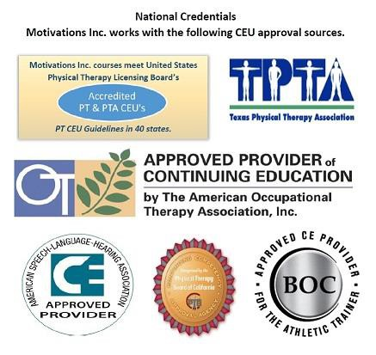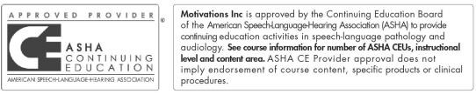
A Workshop for Speech and Occupational Therapists and Assistants and Nutritionists.

This is a two-day course focusing on how to approach, diagnose and treat pediatric feeding and swallowing disorders.

8:00 am – 5:30 pm
# 306 CAN-EAT Approach
…Using medical, motor, & behavioral strategies in pediatric feeding
Instructor
Krisi Brackett, MS, CCC-SLP
249 Venice Way #3303 Myrtle Beach, SC 29577
P: (800) 791-0262
F: (815) 371-1499
admin@motivationsceu.com www.motivationsceu.com
Accredited Continuing Education Courses
C E U
Motivations, Inc.

Motivations, Inc.

SUMMARY: Research indicates that the prevalence of pediatric feeding and swallowing disorders is 80% in the special needs population and 20% in typically developing children. Therefore, most pediatric clinicians will encounter this disorder in some form or another. Feeding disorders come in all shapes and sizes, such as coughing/choking during meals, poor oral-motor skill acquisition, food refusal, oral aversion, g-tube dependence and more. One must be versed in oral-motor and swallowing techniques, respiration, GI issues, nutrition, motor/postural alignment, and behavioral strategies. This is a two-day course focusing on how to approach pediatric feeding and swallowing disorders, how to diagnose and prioritize treatment options, and ensure successful outcomes for you and your patients. Day one will concentrate on medical and nutritional intervention strategies, while day two will focus on evaluation and therapeutic intervention. If children are available, there will be 1-2 live evaluations.

PRESENTER: Krisi Brackett MS SLP/CCC is a Pediatric Feeding and Dysphagia Specialist with over 20 years of experience. She is currently Co-director of the UNC Pediatric Feeding Team at the NC Children's Hospital, UNC Healthcare, Chapel hill, NC. The team consisting of pediatric GI, speech and nutrition provides multidisciplinary feeding intervention to the birth-18 population using a combined medical, nutritional, motor, and behavioral approach. . She is also an adjunct faculty member at the Division of Speech and Hearing Sciences, UNC– Chapel Hill. Krisi publishes the popular feeding blog, www.pediatricfeedingnews.com. Krisi is currently assisting with several pediatric feeding research projects as part of the feeding team and with the UNC research group, The Feeding Flock (http://feedingflock.web.unc.edu/). She performs MBSS and FEES in the pediatric population. She is certified in pediatric neuro- developmental training and is a member of ASHA. Krisi lectures nationally on medical management and therapeutic strategies for handling this special population. The instructor has no relevant financial or non-financial relationships to disclose.

OBJECTIVES: Upon completion of this course, the participant will be able to:
- Explain how feeding disorders develop, the basis for most problems and what maintains them over time
- Describe how gastrointestinal disorders such as reflux, dysmotility and pain affect feeding in a child
- Indicate the differences between a modified barium swallow study and a fiberoptic endoscopic evaluation of feeding and how you would choose one over the other when evaluating a child’s swallowing function
- Explain how to prioritize treatment strategies with a pediatric patient with a feeding disorder
- List examples of behavior techniques to use to improve acceptance of bites of food.

FORMAT: This is a 16-hour course equivalent to 1.6 CEUs. This course is offered for 1.6 ASHA CEUs (Intermediate Professional area). AOTA: Motivations, Inc. is an approved provider of continuing education by the American Occupational Therapy Association #4002, for 16 contact hours - Intermediate Level Occupational Therapy Process: evaluation, intervention. The assignment of AOTA CEU's does
not imply endorsement of specific course content, products or clinical procedures by AOTA.

 | Day One |  | Day Two
 | 8:00-9:30 am | Introduction: An overview of pediatric feeding | 8:00-11:00 am | Instrumental Swallow Evaluation: MBSS vs.
 |  | issues including a framework from which to |  | FEES. Pros/Cons.
 |  | address these issues and review of anatomy of | 11:00-11:15 am | Break
 |  | the digestive tract and oral motor patterns. | 11:15-12:00 pm | Prioritizing Intervention: What comes first to get
 | 9:30-10:30 am | GI issues and feeding: sorting |  | the best results.
 |  | gastroesophageal reflux, motility and pain | 12:00 - 1:00 pm | Lunch (on your own)
 |  | issues and how they relate to feeding | 1:00 - 2:30 pm | Intervention Topics:
 |  | problems. |  | a. Medical (nutrition, GI)
 | 10:30-10:45 am | Break |  | b. Handling/posture alignment
 | 10:45-12:00 pm | Continue GI issues | 2:30 - 2:45 pm | Break
 | 12:00 - 1:00 pm | Lunch (on your own) | 2:45 - 3:00 pm | Continue Intervention Topics:
 | 1:00 - 2:30 pm | Nutrition for the feeding therapist: Nutrition |  | a. oral-motor/sensory (infants, toddlers)
 |  | basics that relate to feeding disorders |  | b. swallowing
 | 2:30-2:45 pm | Break |  | c. ribcage
 | 2:45-4:00 pm | The evaluation process: case history, oral and |  | d. behavioral intervention
 |  | gross motor evaluations, respiration, nutrition, |  | e. service delivery: out-patient, intensive
 |  | feeding, assessment and recommendations. |  | team approach
 | 4:00-5:30 pm | Case studies and Adjourn | 3:00 - 4:00 pm | Special topics:
 |  |  |  | a. tube feeding (bolus vs. continuous)
 |  |  |  | b. preemies
 |  |  |  | c. cranio facial kids (clefts, micronathia, etc)
 |  |  |  | d. food refusers/behavioral feeders
 |  |  |  | e. trachs
 |  |  | 4:00-5:30 pm | Discussion and wrap up /Adjourn
Course Offerings  For course location details and registration, please visit: w |  |  |  | ww.motivationsceu.com

